Here’s how to proceed – Unplug the power supply (with the RED TAG) from the RF Module:
- Remove motor cover and remove wire tie with pliers (just clamp down on it and twist it until it comes off)
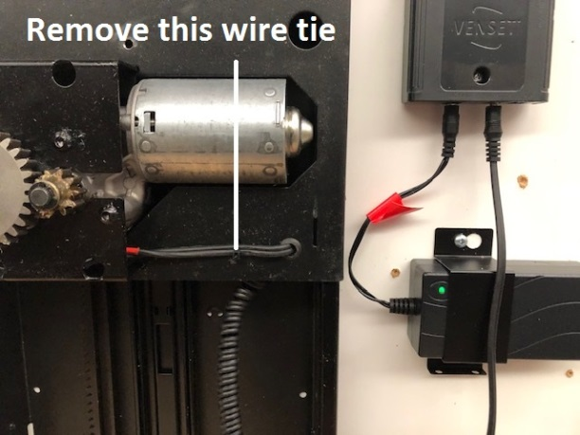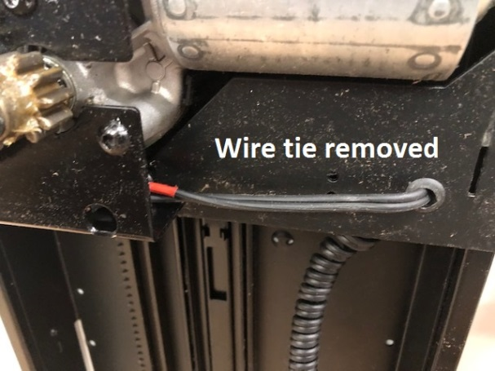

- Pull several inches of the lift wire through the hole and then snip the wire
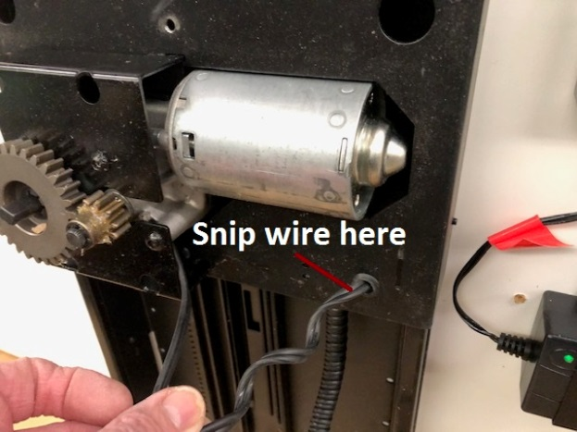

- Now, find the lift wire where it plugs into the RF Module (receiver) – the power supply has the RED tag on it. Pull up from the bottom as much of the lift wire as you can and snip the wire
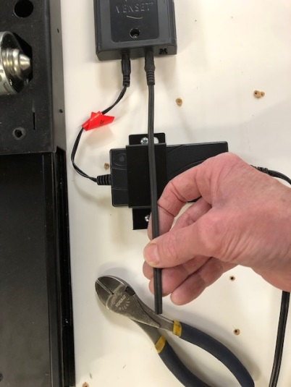
- The wire is really two wires surrounded by insulation. Place a knife blade in between the two wire and push down hard. Now you can separate the wires. After separating the wires, gently cut away about a ¼” – ½” of insulation at the end. Do the exact same thing with both ends of your lamp cord.
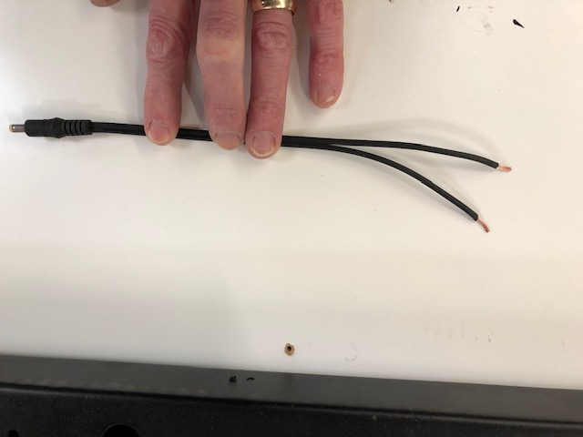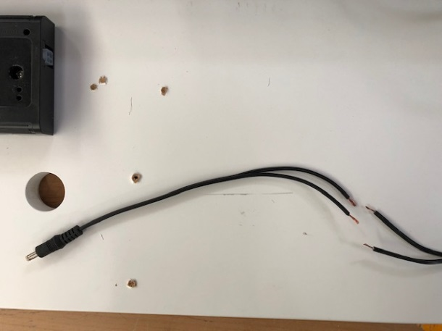
- Take one wire from the lift cord and one from the lamp cord. Hold them together and twist the bare wires together in a clockwise fashion. Then screw on a wire nut (clockwise) until tight. Then do the other two wires.
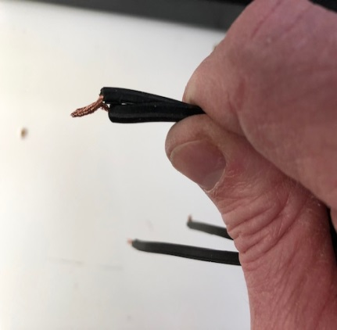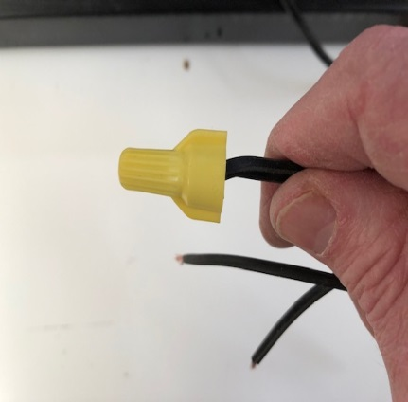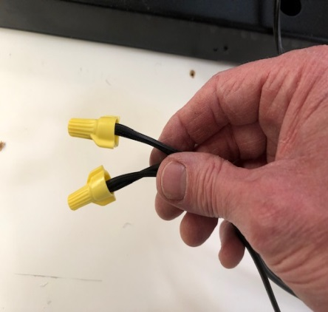
- Take the other end of the lamp cord and attach (as you did directly above) it to the lift wire coming out of the motor.
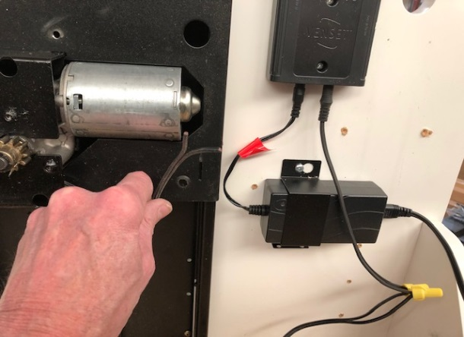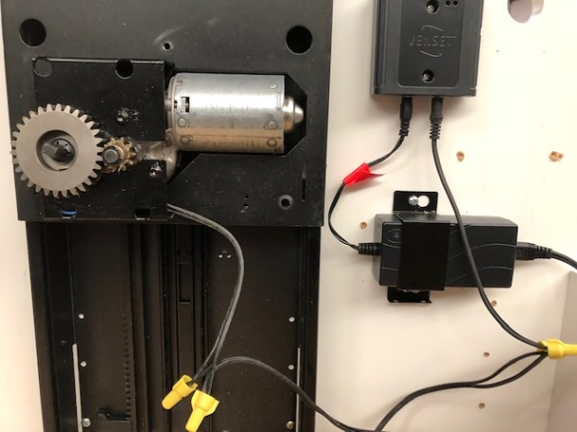
- Last thing – you can use a wire tie (like that on a load of bread) to secure the lift wire to the lift plate. Use that hole where the curly cord went through the lift plate
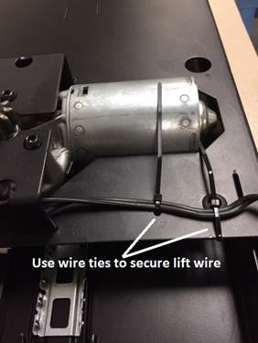
- Finally, raise and lower the lift several times to see how the wire falls. If it looks like it might catch on something , consider securing it to the cabinet wall with a strip of elastic

