Whisper Ride 750 (4050.845.060) Trouble Shooting (repairing the lift wire)
The following instructions are for repairing a TS 750 lift wire. This tutorial is based on the lift being at least halfway extended (up). If the lift is all the way down, please call Wood Technology: 800-231-9522, Option 1, ext. 19 for assistance.
Here is a quick outline for when the lift is up:
- Raise the lift. If the lift is already up, then unplug the lift wire from the RF Module. If the lift is up part of the way, reach underneath the front plate of the lift and feel for the curly cord (like a phone cord) and pull it down (see image below) while pushing the up button on the remote (push only once) or manual switch (push continually). Keep moving the curly cord around until the lift moves upward. Once the lift is up, unplug the lift wire from the RF Module.

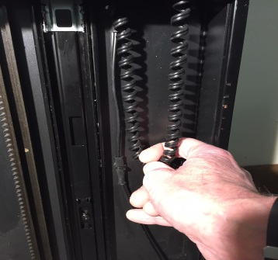

- With the lift in the up (extended) position, remove the motor cover (one Allen screw) and you’ll see the lift wire coming out of the motor assembly. At the point where the wire goes through the holes in the lift plate, pull a couple of inches of that wire through the hole.

- Snip the wire so you have about 4 or 5 inches (10cm-13cm) of wire extending from the motor assembly.

- Next, snip the wire exactly where the breach is in the picture. That will leave the curly cord free. You can pull that out of the lift and discard.

- Remove all the wire ties holding the flat part of the lift wire to the lift. This will give you about 30-35” (76cm-89cm) of the flat wire with the plug.

- Connect the loose ends of the plug wire to the loose ends of the motor wire using wire nuts. You want to test the lift to make sure the up button on the remote makes it go up. If it goes down, then reverse the wires and secure.

This is important – the black box was probably mounted near the bottom of the lift. You’ll need to mount the RF Module about halfway up the lift. So, now the RF Box will be about 17” (43cm) up from the bottom of the lift. You should have enough wire to accomplish this location. You’ll have to mount the power supply close to the receiver (control box) as the cord extending from it is short.
- Run the lift up and down to make sure the wire raises and drops without obstruction and you are finished.

(Page 2)
The following tutorial is for when the TS 750 lift is in the up position. See A below for a quick way to raise the lift manually.
- Remove the motor cover with an Allen wrench (image 1 & 2).
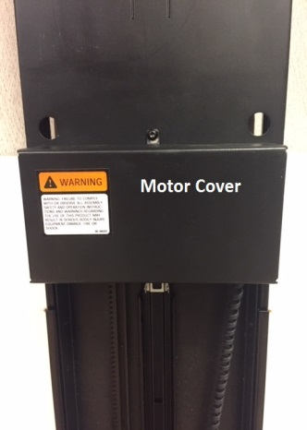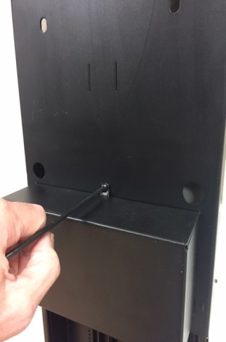
Image 1 Image 2
- Snip the wire tie holding the lift wire to the front plate and pull out 2-3” of wire (images 3 & 4).
- Snip the lift wire so you have 5 or 6” extending from the motor assembly (image 5).
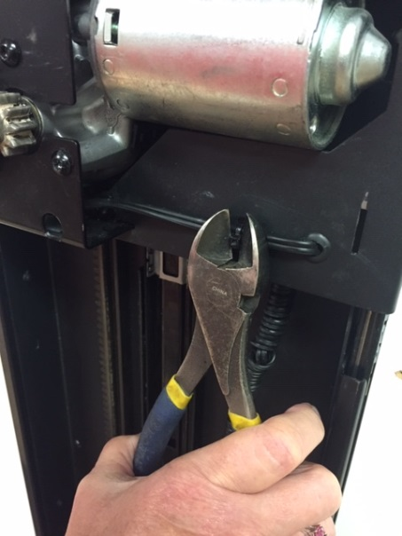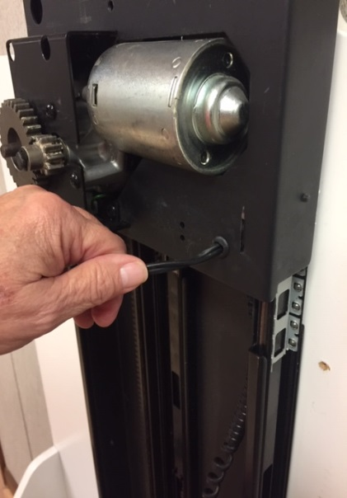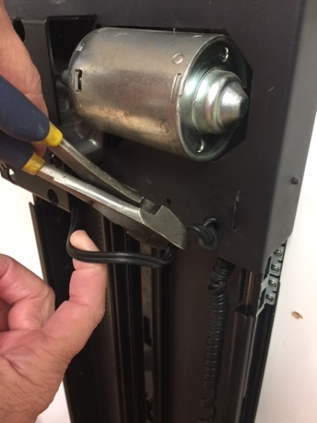
Image 3 Image 4 Image 5

(Page 3)
- Snip the lift wire at the point where the straight wire becomes a curly wire (image 6)
- Remove the wire ties holding the flat wire to the lift (image 7)
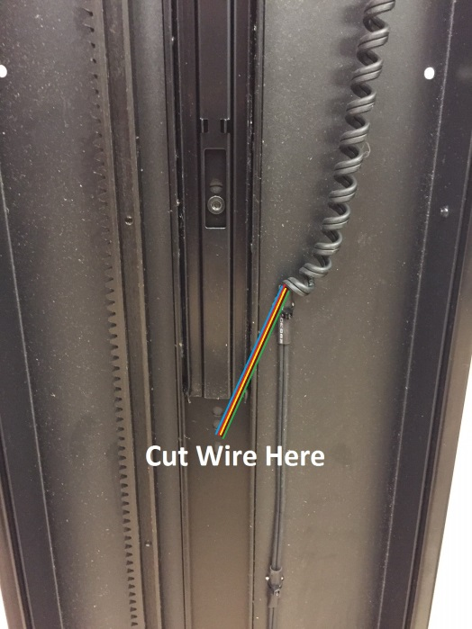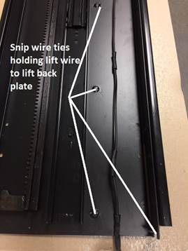
Image 6 Image 7
- Connect the loose ends of the plug wire to the loose ends of the motor wire using wire nuts (image 8). You will want to test the lift to make sure the up button on the remote makes it go up. If it goes down, then reverse the wires and secure (image 9).

- Use wire ties to secure the lift wire to the lift plate to the right of the motor (image 10).

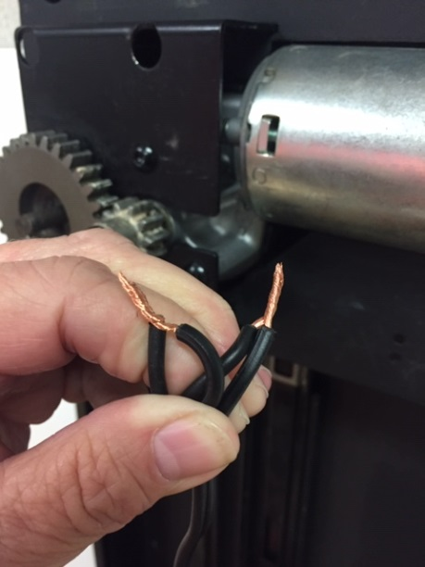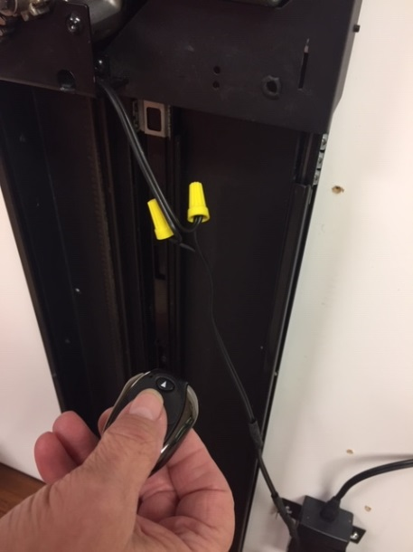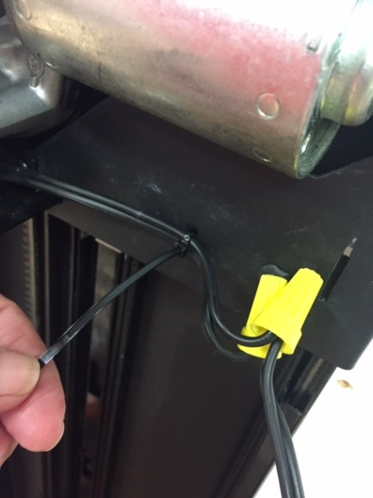

Image 8 Image 9 Image 10

(Page 4)
- You will need to re-locate the black box and power supply, probably mounted near the bottom of the lift. Secure it to the right of the lift, about 20-21” up the bottom (image 11). You should have enough wire to accomplish this location. You’ll have to mount the power supply close to the receiver (control box) as the wire extending from it is short.
- Secure the lift wire to the bottom of the vertical TV Mounting Bracket (image 12) with a wire tie or, if you need more length for the wire, a piece of string or small cable. Run the lift up several times to make sure the lift wire rises and falls without problem (image 13).

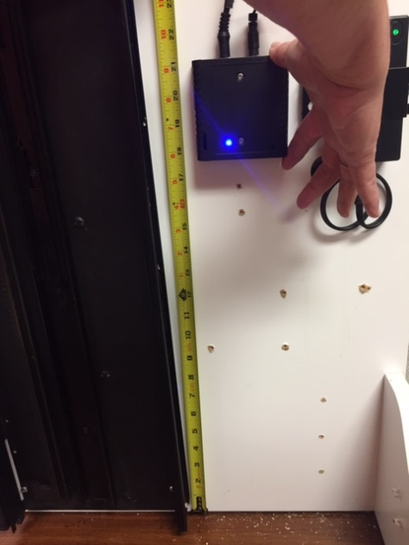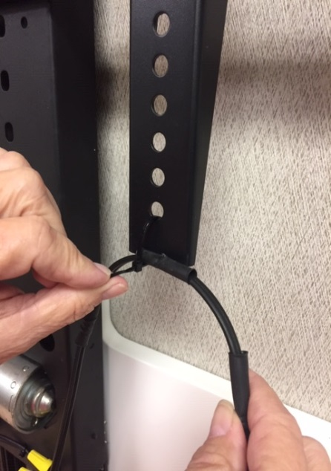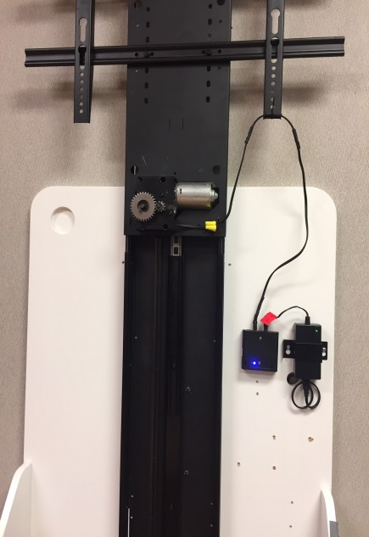
Image 11 Image 12 Image 13

Please contact tech support Wood Technology at 800-231-9522, Option 1, ext. 19 with any questions.

Wood Technology, Inc.
Ph. 800-231-9522 / Fax 919-542-2727
www.woodtechnology.com

